CYLINDERS
Pearson Edexcel - Tuesday 11 June 2019 - Paper 3 (Calculator) Foundation Tier

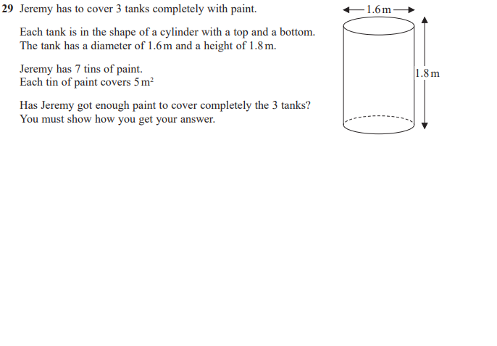
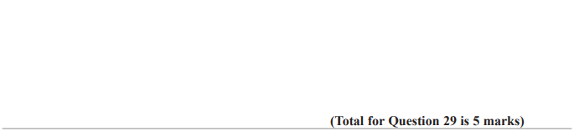

OCR Tuesday 6 November 2018 – Morning (Calculator) Foundation Tier
